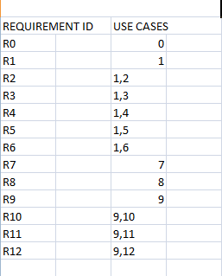

REQUIREMENTS ID REQUIREMENT NAME

R0 visit website

R1 : login

R2: placement news

R3: previous question papers and aptitude test

R4: professors contacts

R5: alumni contacts

R6: student activities and achievements

R7: develops website

R8: update website

R9: manage files

R10: upload files

R11: delete files

R12: add content